# *Web Programming I (420-C10-HR)*

# *Lab 7 – Web Design Part I*

Date assigned: Tuesday, October 6, 2015

Date due: **Tuesday, October 6, 2015, at the end of your lab period**

**Learning Objectives**

Upon successful completion of this lab exercise, the student will be able to:

* Understand the basics of Website Design

To do:

**Lab Set-Up**

1. Save this document with the name **YourUserName_C10_L07.docx** in the Labs folder for this course on your H drive (H:\420-C10\Labs). We have not gotten very far yet into website design so parts of today’s lab could be challenging. You can refer to Chapter 5 of your textbook, particularly page 228 and 229.

**Part A: What is a Good Website?**

1. Develop a checklist of at least 10 items to look for in evaluating a website’s design. The sky is the limit here; what things do you look for in a website when you look at one. For example, you may include things from different categories such as: overall layout, navigation, colour/graphics, use of multimedia, accessibility, functionality, etc. Anything that you feel is important. In POINT FORM, explain why the item you chose is important when determining whether a website has a good design or not.
2. Smart phone compatibility- A lot of sites require too much work when looking at them on a phone.
3. Navigation is easy- If finding your navigation links requires you to look all over the page instead of them just sitting at the top or side of the page.
4. When there’s a small difference between text color and background color it gets very difficult to read.
5. The graphics don’t slow down the web page. When someone has an animated gif as the background to their web page then the site could take a very long time to load, which is horrible
6. Information is easy to find- like the navigation, if it becomes a chore to find my information, I’ll likely just go to a different site.
7. Everything is put into appropriate elements. When everything is a paragraph instead of having a header, paragraphs, lists, etc., things can become difficult to read.
8. Content does not include outdated material- It’s horrible when you’re trying to look something up that’s recent and you get all sorts of articles that are 4 or 5 years old but they don’t state that so you end up thinking they’re recent.
9. When sites have animated gifs that you don’t have an option but to let them run, that’s quite frustrating because it can be both distracting and slow down the browser.
10. When a website has a good opening line before you ever have to start scrolling, that can be really nice.
11. Balance of text and white space is super important. Having half of a page being blank makes it look empty and like the author just wanted to take up room. Having too much text makes information harder to find and makes you less likely to want to read it.
12. Using this checklist and any other factors you feel necessary evaluate each of the following sites. Some of the sites are really bad and some of them are artistic and you may like them. Make sure you navigate to a number of pages in each site. What is your overall impression of the site based on the design that you see?
13. <http://www.leoburnett.ca/>

This site has a lot of blank space, but otherwise is pretty good. Finding different menus is easy and the contrast between colors is very easy to read. The videos don’t start running the moment you scroll over them and they stop the moment you want them to. However there’s too much information in the videos that you can’t just read, which is bad. There isn’t a lot to load, so the site is very fast. When you first open the site, there isn’t any immediate useful information.

1. <http://anselme.homestead.com/AFPHAITI.html>

This site is impossible to look at. The site is nothing but pictures and obnoxious gif, the embedded twitter pages are horrible. All of the links are shoved onto the left hand side of the screen and are just sprawled out all over the place. There’s no organization what so ever. At least all of the links actually work.

1. <http://art.yale.edu/>

This site is horrible too. 17 different menus is a little bit too much. The site is crammed with pictures and each menu provides so little information and forces you to click other links to actually find any information. There’s pictures that are really distracting as well as background animated gifs that I don’t really want to see. The contrast between text color and background color is never bad though.

1. <http://www.webydo.com/>

The idea behind the layout of the site is super cool, but I don’t want that much stuff moving around when I want to try and find one piece of information. Looking up at the menus you also can’t immediately tell which page you’re on. The home page has its information displayed quite efficiently and gives you an immediate idea of what to expect from this site. The moment you start scrolling, they have all of these moving things which, while successfully making something that looks impressive, they make things look fast and complicated, which isn’t the first impression a business wants to give.

1. <http://www.thecanadianencyclopedia.com/en/>

First of all- The site took several minutes to open. I opened it once successfully, then it crashed and wouldn’t let me refresh it. So I closed it and came back to reopen the link and 3 times opening the page got stopped because it was taking too long. And it wasn’t the internet’s fault, because YouTube opened in about a second. The different categories of information are incredibly full, which makes sense, it’s an encyclopedia, but still. I wanted to see the different gamer’s articles, and that took about 30 seconds to load just so I could find that there was only 16 different articles.

**Part B: Website Evaluation**

1. We will be exploring web page design, including navigation design, colour choice, and the design principles of contrast, repetition, alignment and proximity.

For each of the figures (1 – 4) at the end of the document answer the following questions (you may want to go to the sites themselves and have a look. URLs are posted with the figures).

* + 1. Who do you think that the target audience of the site is? What age group? What demographic?
    2. What types of navigation are evident? Does that fit with the target audience?
    3. How do the colour and graphic choices improve or take away from the site? How does that work with the target audience?
    4. Some design principles we will discuss include contrast (how much the colours are unlike each other), repetition (repeating themes, colours, words, images), alignment (having things line up with each other on the page), and proximity (keeping similar items close together). How are these 4 design principles applied to the sites below (or maybe they aren’t)?

**Part C: Website Design**

1. Each of the following sets of sites that have a similar target audience. For each set, review the sites and describe:

* What you think the target audience is for the site (age range, interests, jobs, etc.);
* The similarities in site design that attempt to attract their target audience;
* The differences in site design and what that does to attract their target audience;
* Two things you like about the site design of each site and two things that could be improved in the site design for each site;
* Which of the sites in the set does a better job of attracting their target audience; and,
* Which of the sites in the set has a better overall design and why.

1. <http://www.ironmaiden.com> **and** <http://www.metallica.com>

The target audience for Iron Maiden seems to be more of a young 20’s range whereas Metallica seems to be a slightly more mature site. Both sites try to attract audience with their dark color scheme and heavy feel to them. The Iron Maiden site however is full of pictures that contain their iconic zombie and the Metallica site has all of their pictures and videos available at the bottom of the page, but they aren’t immediately visible.

On the Iron Maiden site, it’s super easy to find their music. They have their latest album at the top, then everything sorted between albums, singles, DVDs and then their best of. The site is very consistent. The Iron Maiden banner at the top never moves, the background never moves and the social media links never move. The site is very consistent. A little too consistent with their use of the zombie picture, but that’s mostly cause I don’t like zombies. The website can be slow to open different pages and all of the pictures load one at a time. Their font is also very wide and heavy without a lot of spacing in some places making actually reading more difficult.

On the Metallica site, there’s a lot of drop down bars and more bars within those which makes it seem like there’s just a lot to find. They also have their news on their home page, one article which I think is important for it to be there, but I would make more sense to me to have their latest updates there. But like I said, the site feels like it’s trying to attract an older, more mature audience. The site has much easier to read font than the Iron Maiden site, and you aren’t forced to look at all those pictures of zombies. Their pictures are neatly tucked away at the bottom. The Metallica site loads very quickly.

Overall, I think the Iron Maiden site is better. Information about their music and tours is much easier to find and they appeal more to their audience. Young people like very visual information, so having a lot of pictures on their site that link to things I think is very effective. The only advantage I think that the Metallica site has is that it loads much quicker.

1. <http://www.ottawa67s.com/> **and** <http://senators.nhl.com/>

The Ottawa 67’s site looks like it’s appealing to a slightly younger audience. The whole thing is full of bright colors and is full of pictures. The Senators site has a darker color and although is still full of pictures, they’re more dramatic in the moment type shots as opposed to the more family oriented looking 67’s site.

The senator’s site is cluttered. There’s links everywhere and the menus have up to 14 different menus and then some of those ones have even more submenus. It’s very complicated to look at and not the kind of site I’d want to try and find anything useful on. The website is very frequently updated, with one example of it having just been updated a few days ago in the new articles. The site is also very consistent in the way the information is displayed. Which considering how poorly it’s put out in the first place can be taken as either a good thing or a bad thing, but consistency is nice. They always have their logo in the same place with the same picture of one of their players on the side ready to start.

The 67’s site, much like the senators site, is super cluttered. 17 different submenus in one menu is a little ridiculous. They also have this big heading on the side written in big letters “Tackling Women’s cancer”. Which is awesome, but there’s absolutely no other information about it. The site, like the sens site is very fast and very consistent. Their font is easy to read.

Overall, I have no idea which site I like more. I dislike both of them, a lot. I think the 67’s site is marginally better at appealing to a more family oriented audience because of its brighter colors. The sens site doesn’t look as much like somewhere you’d want to take younger kids. The 67’s site is overall better due to a slightly lower volume of needless links and pages and menus all over the place.

Remember, you will have to explore more than the homepage of each site. Among other things, you will need to look at the criteria for good design that we developed in class.

**To submit**

When you have completed the lab exercise copy the YourUserName_C10_L07.docx document to Moodle.

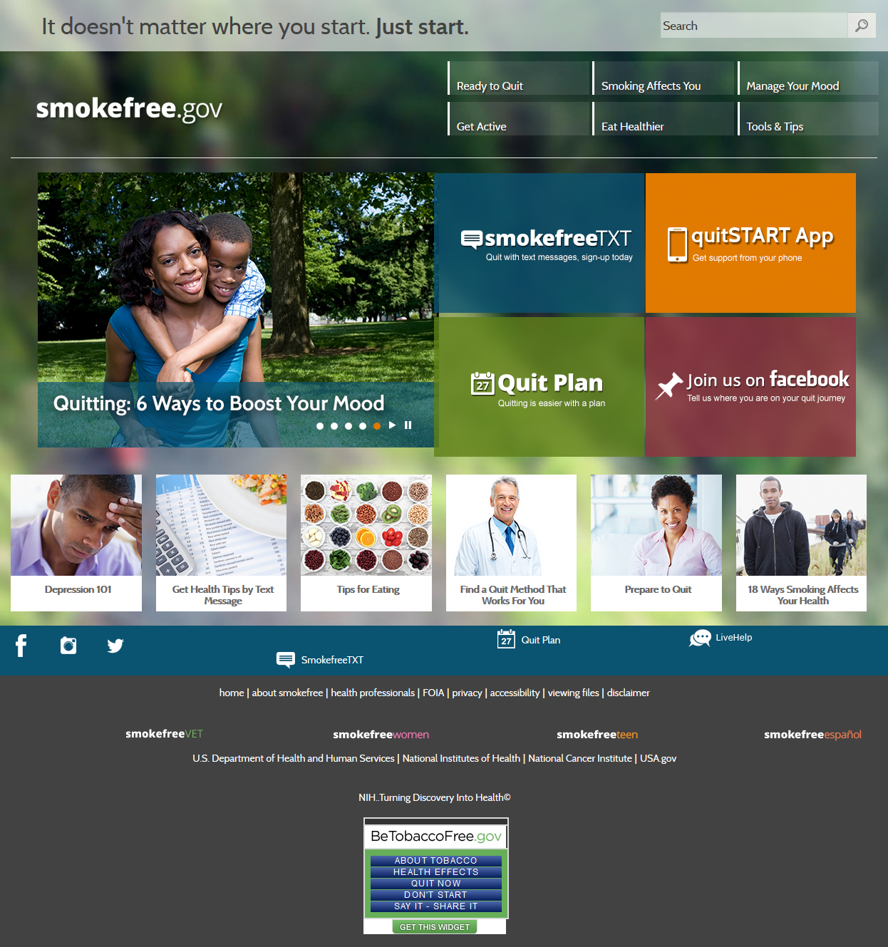

Figure 1: smokefree.gov

1. Who do you think that the target audience of the site is? What age group? What demographic?
2. What types of navigation are evident? Does that fit with the target audience?
3. How do the colour and graphic choices improve or take away from the site? How does that work with the target audience?
4. Some design principles we will discuss include contrast (how much the colours are unlike each other), repetition (repeating themes, colours, words, images), alignment (having things line up with each other on the page), and proximity (keeping similar items close together). How are these 4 design principles applied to the sites below (or maybe they aren’t)?

The target audience for the site is people in their 20’s-50’s who smoke and want to quit. The navigation is put together well for the site. The home page has 4 main links, one to receive texts, the other an app, and the 3rd a tutorial to start a plan to quit smoking. The site tells you that it’s not just about smoking, it’s about overall health, so they also have different tabs to help you get more healthy in other ways, both physical and mentally. The site has a white and green color scheme to promote the idea of purity and natural. The color contrast on this site is really good. The white background with black text is just easy to read. Even the top of the different screens has an opaque picture of nature with white text on top that is easy to read. No matter which tab you click on, the site has the same format either way. 3 main articles inside colored boxes, the order of which remains consistent throughout the site, the underneath links to several other articles neatly put in one column. The alignment on everything is good. They could afford to use some amount of indenting between the headings and the paragraphs, but everything is very neat.

The information inside each article is very relevant to the topic and title. The information is all very easy to find with links being close to each other in relevant places.

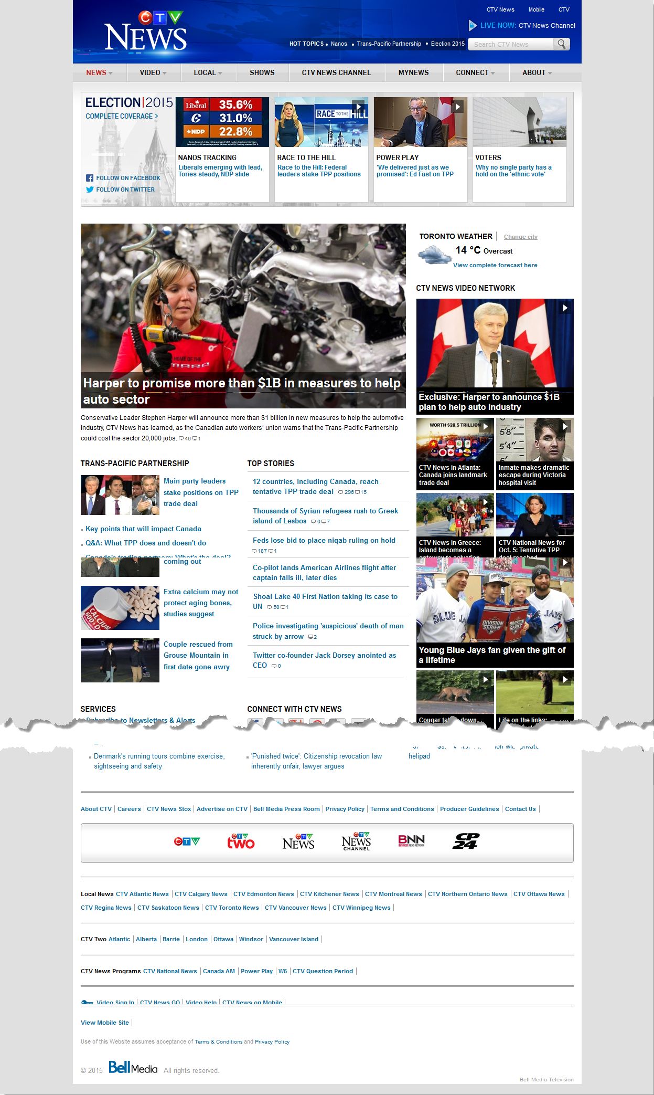

Figure 2: www.ctvnews.ca

1. Who do you think that the target audience of the site is? What age group? What demographic?
2. What types of navigation are evident? Does that fit with the target audience?
3. How do the colour and graphic choices improve or take away from the site? How does that work with the target audience?
4. Some design principles we will discuss include contrast (how much the colours are unlike each other), repetition (repeating themes, colours, words, images), alignment (having things line up with each other on the page), and proximity (keeping similar items close together). How are these 4 design principles applied to the sites below (or maybe they aren’t)?

Target audience of the site is really anyone who cares about the world they live in, anyone who wants to be informed, anyone who wants to be aware and learn about these things instead of hearing about them from a friend who won’t necessarily give an accurate retelling of something. However, it’s also unfortunately mostly adults who read the news, so the sites are directed towards adults. The new is divided nicely into different categories such as political news or sports or science and technology, world news, local new, etc. The color is mostly white background with black font, making things easy to read, without feeling the need to draw in the attention of someone younger who has a much shorter attention span. The site is consistent, with the CTV logo at the top with a blue background to it. A white background to the rest of the page and a majority black text. The text is aligned properly into a different number of columns depending on where you are on the page. However each column is nicely aligned. When opening an article, the information on each page is also aligned nicely. The different types of news are organized and kept together, so all of the entertainment news can be found together, which makes finding related articles quite easy.

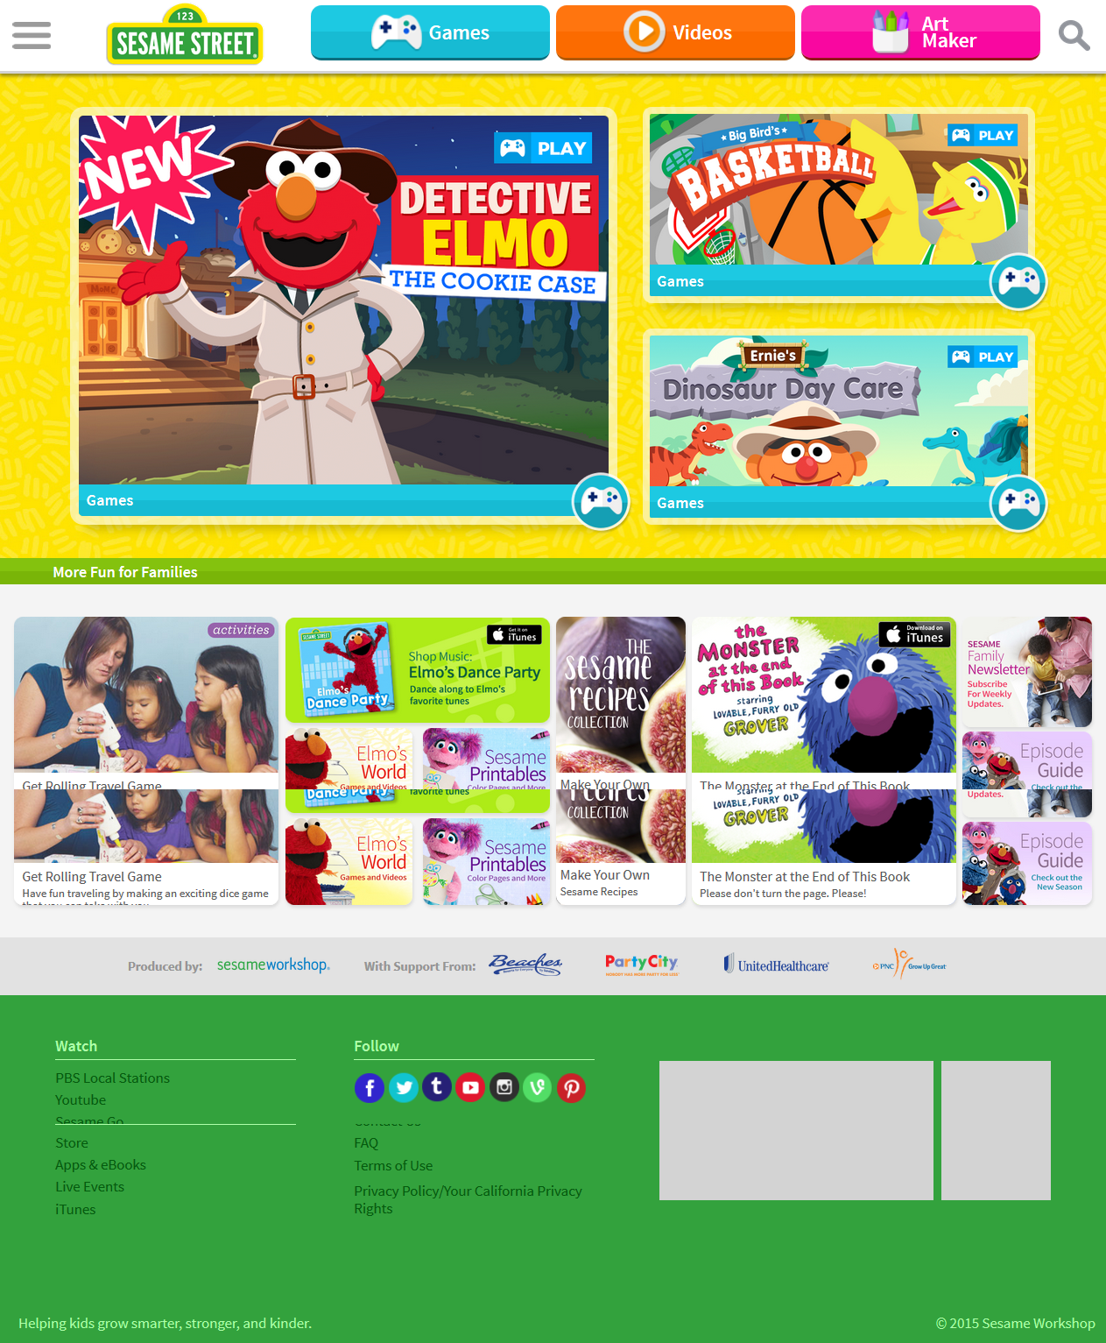

Figure 3: www.sesamestreet.org

1. Who do you think that the target audience of the site is? What age group? What demographic?
2. What types of navigation are evident? Does that fit with the target audience?
3. How do the colour and graphic choices improve or take away from the site? How does that work with the target audience?
4. Some design principles we will discuss include contrast (how much the colours are unlike each other), repetition (repeating themes, colours, words, images), alignment (having things line up with each other on the page), and proximity (keeping similar items close together). How are these 4 design principles applied to the sites below (or maybe they aren’t)?

The target audience for this site is obviously much younger than any of the others. It’s directed towards toddlers, likely ones who are looking at the site from their parents tablet from the looks of the layout of the site. Kids are very visual and as such, they’ve made their navigation tools very visual. A picture of a remote for their games page, a little play symbols for their videos, etc. The site is very colorful to attract the attention of younger children. The font is also very larger and always very easy to read for younger kids who are just learning to read and write. The color scheme of the site is very consistent, however not always idea. Such as on the videos page having an orange background with a navy header and the first video is paused on a purple background, and that doesn’t look good. The site has very little information in text, it’s mostly presented in pictures that are placed in a row with the largest image in the row with column of picture beside the biggest image. It’s not a confusing layout. All of the games are available on one page and the same is true for videos and characters. It’s very easy to find things on the page.

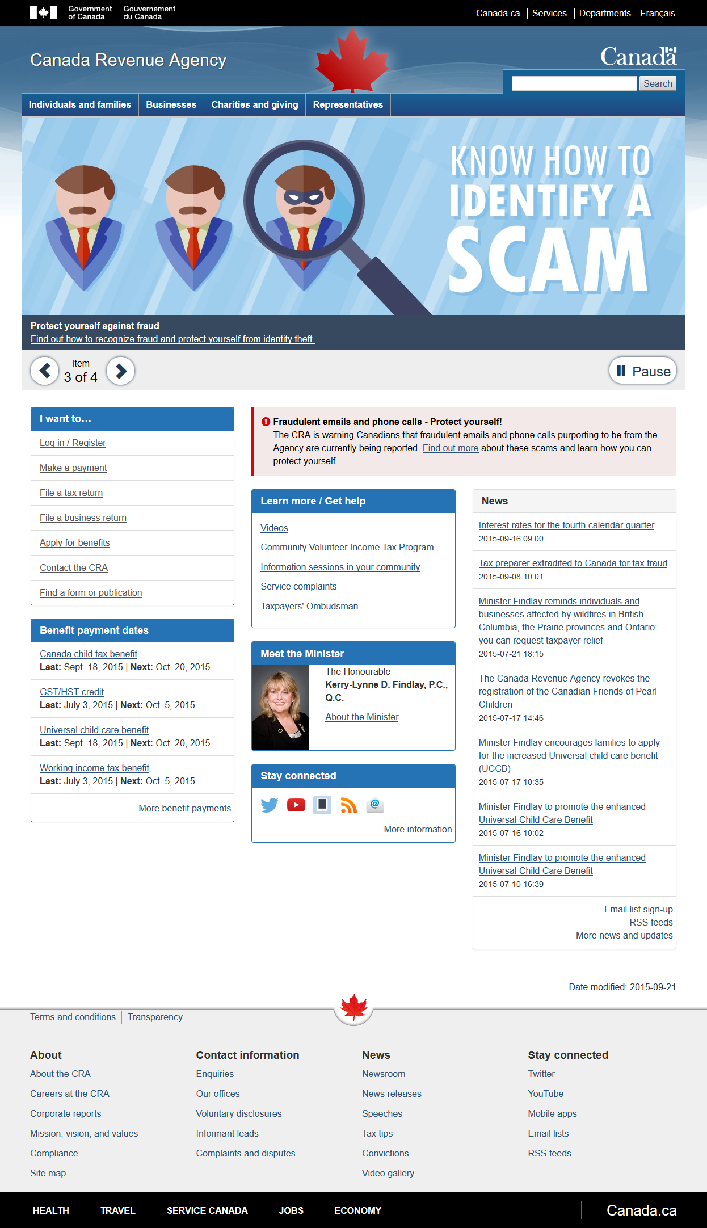

Figure 4: http://www.cra-arc.gc.ca/menu-eng.html

1. Who do you think that the target audience of the site is? What age group? What demographic?
2. What types of navigation are evident? Does that fit with the target audience?
3. How do the colour and graphic choices improve or take away from the site? How does that work with the target audience?
4. Some design principles we will discuss include contrast (how much the colours are unlike each other), repetition (repeating themes, colours, words, images), alignment (having things line up with each other on the page), and proximity (keeping similar items close together). How are these 4 design principles applied to the sites below (or maybe they aren’t)?

Being a government site, it’s meant to appeal much more to middle age people who will be using the site as a source for their work. The site has a white background and black text, a format that all Canadian government sites use. It’s easy to read, but due to the plainness does not attract the attention of a reader. The site is very consistent with its color formatting and layout with the government of Canada written at the top, the name of the branch of government with a search bar and then all information relevant to that branch underneath. The page is aligned with 3 column on every page and then headings with appropriate use of paragraphs and lists inside each article. The information on the site is all relevant to the branch of government and on the site is well organized into different categories.